Methods

Song Hyoseok (송효석)

GEDU501

Prof. Natasha Powell

The proposed method was used to optimize the on-chip link circuit. The proposed method uses three algorithms simultaneously : divide-and-conquer (DnC), particle swarm optimization (PSO) and artificial intelligence (AI). The problem to be optimized by the proposed method is to optimize the on-chip link circuit sizing parameter. The on-chip link circuit is shown in the figure below. (Fig.1)

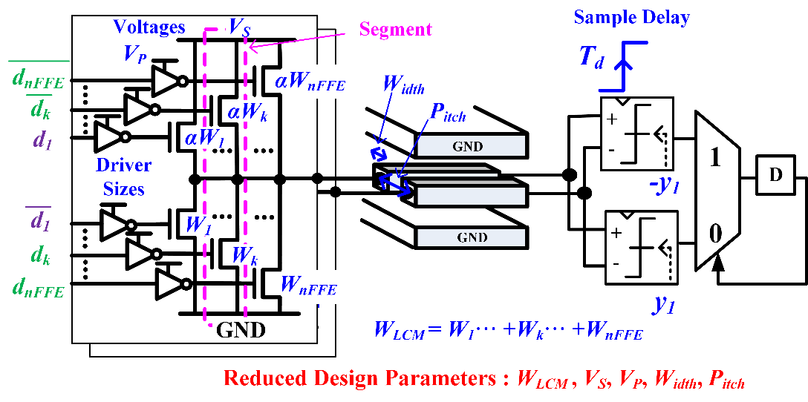

[Fig 1] An on-chip link and key design parameters.

As seen in the figure above, all characters represented by text are sizing parameters that need to be optimized. The sizing parameters of the corresponding on-chip link circuit reach a quantity of dozens. Optimizing all dozens of sizing parameters takes a long time. Therefore, it is necessary to reduce the number of parameters to be optimized. It should be noted here that one sizing parameter affects the other sizing parameters. Thus, parameters whose values are determined by the influence of other parameters using the property do not need to be optimized. In other words, after dividing one large circuit into small modules, each module can be optimized for each module by sharing only parameters that are affected by one another. This is called divide-and-conquer (DnC). If a database is created by dividing the on-chip link circuit by module in the DnC method, it is as shown in the figure below.

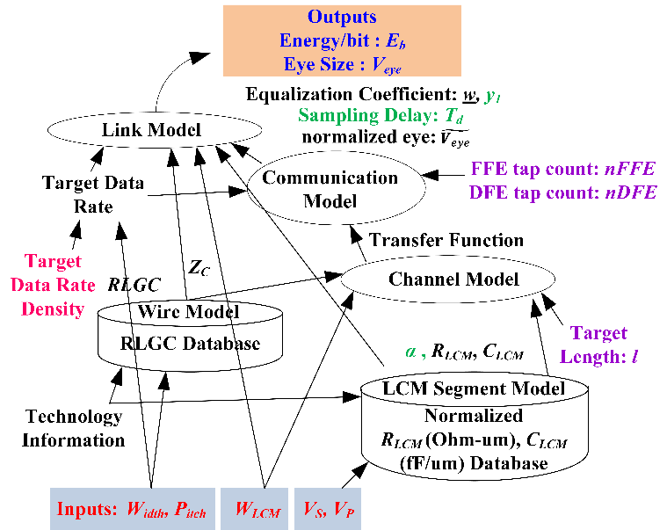

[Fig 2] Database of on-chip link formed by DnC method

The input and output of each model are the letters written in the direction of the arrows, and the number of sizing parameters to be optimized through this DnC method was reduced to five. The five reduced parameters are Width, Pitch, WLCM, Vs, and Vp, respectively. The final outputs from several models are power consumption (Eb) and eye height (Veye). Here, power consumption is a value that should be minimized, and eye height is a constraint that must satisfy a value higher than the target value. In other words, the power consumption is a value to be optimized, and the eye height is a value that needs to be satisfied only with a value equal to or greater than the minimum value which does not need to be directly optimized. In summary, this problem was originally a problem of minimizing power consumption with dozens of sizing parameters, but through the DnC method, it was changed to a problem of minimizing power consumption with only five sizing parameters.

Now, while changing the five sizing parameter values, we need to find the five specific sizing parameter values (Width, Pitch, WLCM, Vs, and Vp) that minimize the power consumption (Eb) while satisfying the eye height (Veye). The most common way to optimize this would be the parameter sweep method, which examines all five sizing parameters, but this takes too long. Therefore, it is necessary to perform optimization in a short time by applying a heuristic algorithm to find the optimal value of the five parameters (Width, Pitch, WLCM, Vs, and Vp) with only certain combinations of the five parameters. The first heuristic algorithm used here is the particle swarm optimization (PSO) algorithm. PSO is an optimization technique that mathematically models the behavior of a herd of animals. The flowchart of the PSO algorithm is as follows.

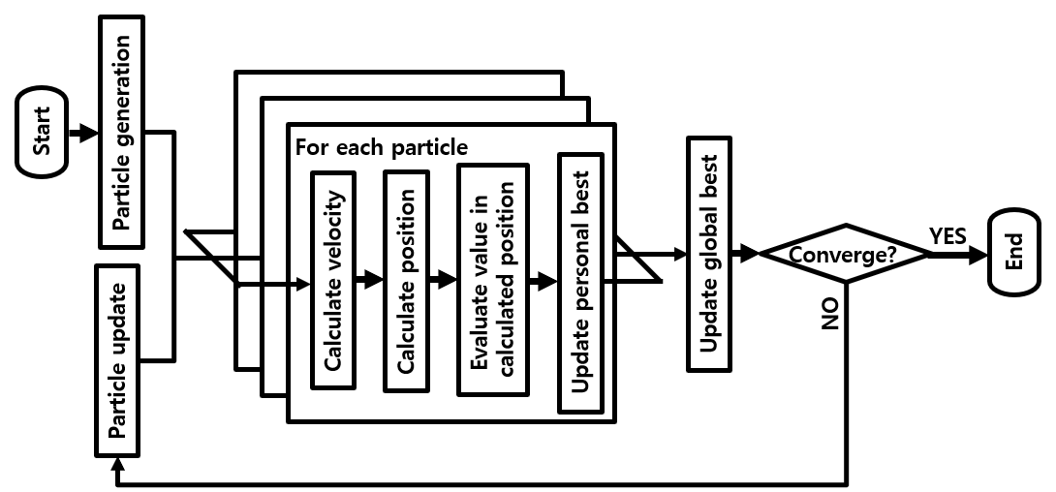

[Fig 3] flowchart of the particle swarm optimization (PSO) algorithm

The PSO algorithm is an algorithm in which particles move around the search space, which is a space where sizing parameters to be optimized are gathered, and particles gradually gather to the optimal value. Each particle has a unique position and speed, and moves to the optimal value by updating the position and speed according to a set rule. The set rule of the PSO algorithm refers to a rule in which the next speed of each particle is determined by the sum of three vectors. The three vectors are the unique inertia vector that the particle originally intends to move, the vector that the particle intends to move with the best value among the explored values, and the vector that all particles try to move with the best value explored. A good value among the values explored by an individual particle is called the personal best, and a good value among the values explored by all particles is called the global best. While the PSO algorithm is running, each iteration updates the personal best for each particle and one global best.

If this PSO method is applied to the on-chip link circuit optimization problem after the DnC process, each particle will find the optimal value only with partial experience, even if it does not go all over the 5-dimensional search space.

However, since the particles have some randomness in this method, there is a problem that even if it is certain that the value is not optimal, the particle experiences a place far from the optimal value in the spirit of exploration, which is a factor that increases the optimization time.

To solve this problem, we finally used artificial intelligence, a heuristic algorithm. We apply artificial intelligence to the PSO algorithm to prevent particles from moving to unnecessary positions. The flowchart of the algorithm applied with artificial intelligence to PSO is shown in the figure below (Fig. 4).

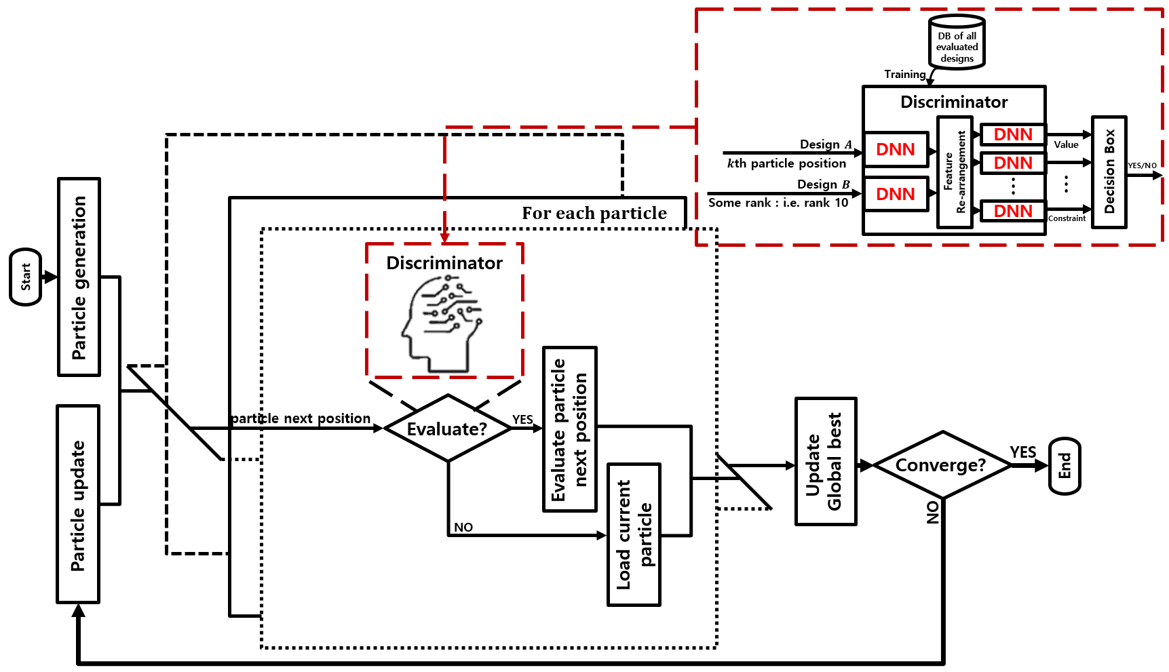

[Fig 4] flowchart of the PSO algorithm with artificial intelligence (AI)

The figure corresponding to the red box in the figure above is the artificial intelligence component. The difference from the existing PSO algorithms is that if the PSO algorithm must move to the next position according to the calculated speed, in the case of the modified PSO with artificial intelligence, the artificial intelligence determines whether to move to the next position calculated or not. The way the AI decides whether or not to send a particle to the next location is by comparing the two values, the new location and the 10th best location (reference location). By comparing these two values, if the AI determines that the new location is better, it moves to the next location and evaluates that location. Conversely, if the artificial intelligence determines that the new position is not better than the reference position, it loads the previous value of the calculated position.

In summary, the proposed method designed a new type of optimization program using all three algorithms, DnC, PSO, and AI, and describes how it is optimized when optimizing an actual on-chip link circuit.

[1] Byungsub Kim and Vladimir Stojanovic, "Equalized interconnects for on-chip networks: modeling and optimization framework," 2007 IEEE/ACM International Conference on Computer-Aided Design, 2007, pp. 552-559, doi: 10.1109/ICCAD.2007.4397323.

[2] K. Hakhamaneshi, N. Werblun, P. Abbeel and V. Stojanović, "Late Breaking Results: Analog Circuit Generator based on Deep Neural Network enhanced Combinatorial optimization," 2019 56th ACM/IEEE Design Automation Conference (DAC), 2019, pp. 1-2.